**Problēmas izpēte un analīze**

Pedējos gados tāda nozare, kā Dropshippings(tirdzniecības modelis, kurā pārdevējs pārdod produktus tiešsaistē, bet fiziski nesaglabā preces savā noliktavā.) sāk pieaugt un aizņemt svarīgu vietu mūsu dzīvē. Tāpēc es sāku pētīt tirgus izmatojot statistiku. Pedējos 11 gadus dropshippinga pardošanas apjoms palielinājās no 1,336 līdz 6,773 milijardiem. Shopify izmanto vairāk nekā 2.1 miljoni lietotāji katru dienu, bet viņš nav vienigais spēlētājs - ir arī Wix, WooCommerce, Volusion, BigCommerce un citi. Tikai 2023 gadā Shopify peļņa bija $3.515 Milijardi. Paņemot tikai 1% procentu no tirgus var nopelnīt 100 miljoni gadā.

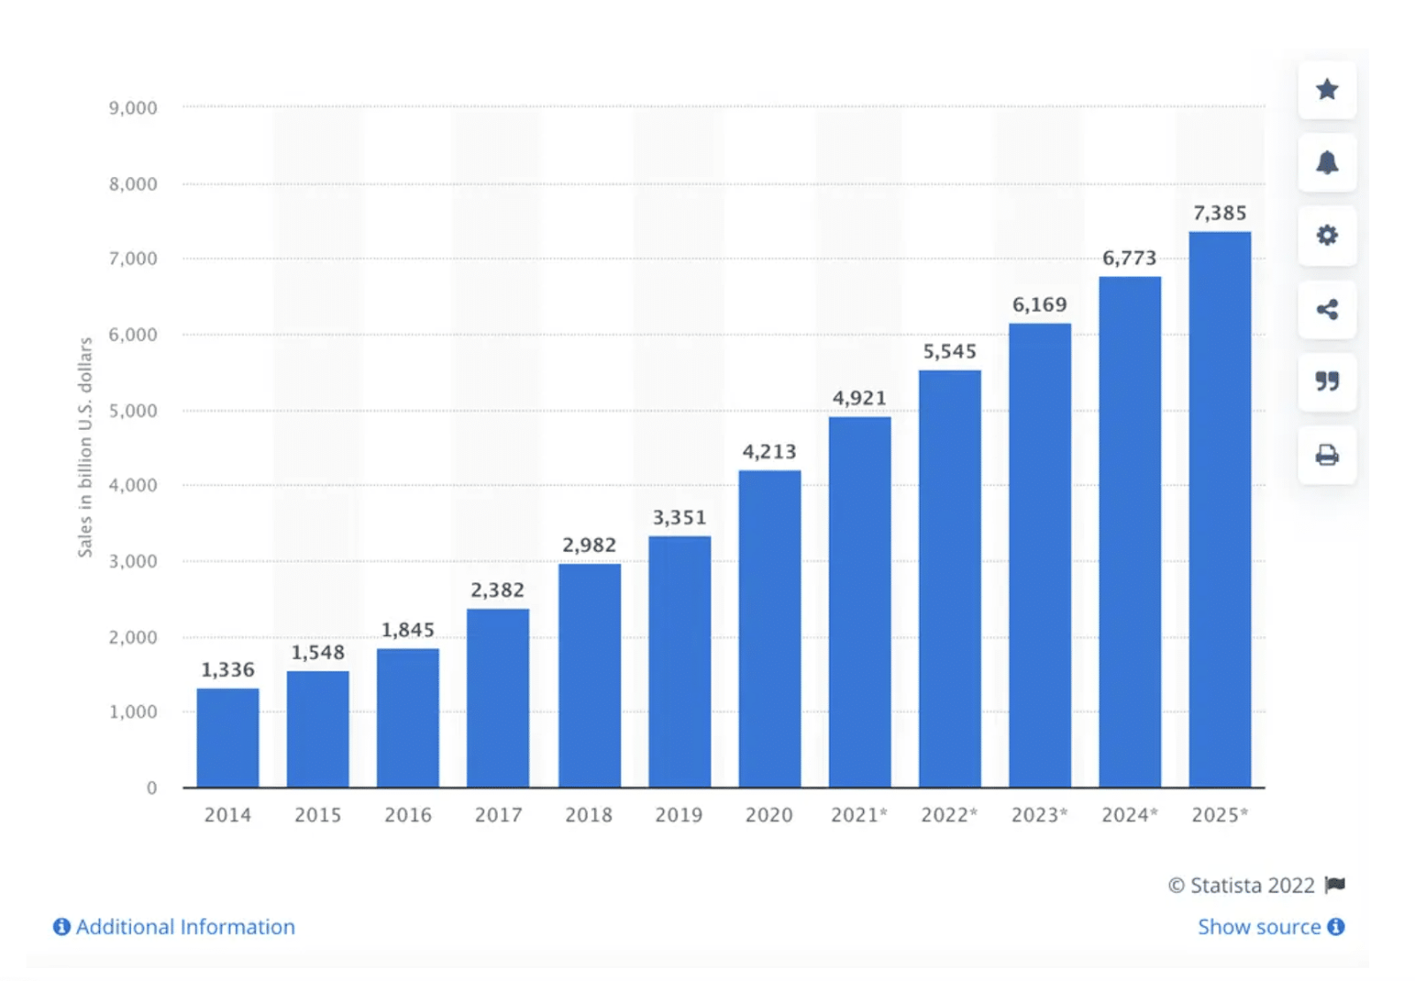

**Programmatūras prasību specifikācija**

Skatoties uz iepriekš minētu statistiku, varam secināt, ka pieprase uz rīkiem, kuri ir tik izmantoti, veidojot dropshipping veikalu, arī augs. Viens no lielākiem spelētājiem šajā jomā ir shopify, bet viņš ir dārgs, bloķē bieži un neatļauj pievienot visus maksājuma sistēmas. Tad es saku veidot savu konstruktoru, kurš atļaus pievienot savus produktus, grupas, atlaides, redzēt visus orderus, mainīt jautājumus, kuri būs uzdotie klientam, pievienot jebkuru maksājumu sistēmu un viss tas būs par fiksētu cenu.

Mana mērķauditorija - būs jauni biznessvaditāji, kuriem būs nepieciešama lēta sistēma, lai apstrādātu klientus online un viegli pardot savu produktu.

Pieiejamas funkcijas:

* Produktu izveidošana
* Promokodu ģenerēšana
* Grupas veidošana
* Jautājumu, kuri būs uzdotie klientam, kastomizācija
* Order Confirmation
* Iespēja saglabāt visus e-pastus marketinga piedavājumiem
* Admin panēlis
* Jebkuru maksājumu sistēmu pieslēgšana
* Kodu kastomizācija

Pamatojums: Visas šīs funkcijas ir nepieciešamas, lai kastomizētu savu individuālu veikalu bez problēmām, lai veidot akcijas, lai informēt klientu par pasūtījuma statusu, kā arī ir iespējams pieslēgt jebkuru maksājumu sistēmu.

Izvelētas valodas:

* Backend: Python(Flask)
* Frontend: HTML, CSS, Javascript

Skices: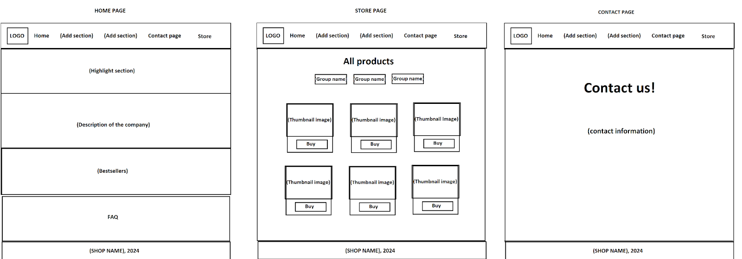

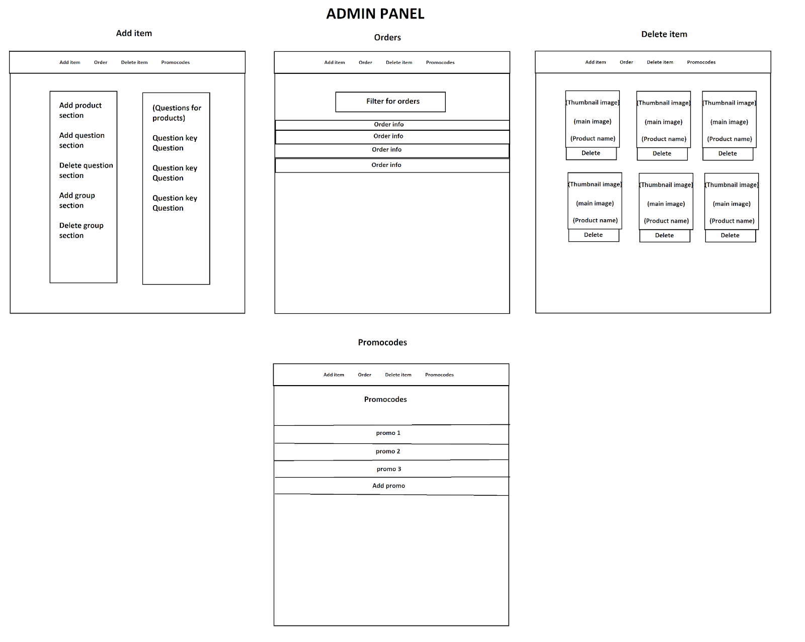

MYSQL SCHEMA:

| DROP TABLE IF EXISTS `affiliate`; CREATE TABLE `affiliate` (  `id` int NOT NULL AUTO_INCREMENT,  `affiliateId` int NOT NULL,  `name` text NOT NULL,  PRIMARY KEY (`id`) );  DROP TABLE IF EXISTS `fkgroups`; CREATE TABLE `fkgroups` (  `id` int NOT NULL AUTO_INCREMENT,  `groupName` text NOT NULL,  PRIMARY KEY (`id`) );  DROP TABLE IF EXISTS `items`; CREATE TABLE `items` (  `id` int NOT NULL AUTO_INCREMENT,  `requiredInfo` text NOT NULL,  `description` text NOT NULL,  `url` text NOT NULL,  `thumbnailUrl` text NOT NULL,  `itemName` text NOT NULL,  `type` text NOT NULL,  `price` float NOT NULL,  PRIMARY KEY (`id`) );  DROP TABLE IF EXISTS `orders`; CREATE TABLE `orders` (  `id` int NOT NULL AUTO_INCREMENT,  `orderId` text NOT NULL,  `orderContent` text NOT NULL,  `status` text NOT NULL,  `order_date` timestamp NOT NULL,  `email` text NOT NULL,  `order_name` text NOT NULL,  PRIMARY KEY (`id`) );  DROP TABLE IF EXISTS `promocodes`; CREATE TABLE `promocodes` (  `id` int NOT NULL AUTO_INCREMENT,  `code` text NOT NULL,  `discount` float NOT NULL,  `timesUsed` int NOT NULL,  PRIMARY KEY (`id`) );  DROP TABLE IF EXISTS `questions`; CREATE TABLE `questions` (  `id` int NOT NULL AUTO_INCREMENT,  `itemKey` text NOT NULL,  `itemQuestion` text NOT NULL,  PRIMARY KEY (`id`) ); |
| --- |

**Programmatūras izstrādes plāns**

1. Prasību izpēta

Visspirms, es izpētīju tirgu, lai uzzinātu kādas funkcionalitātes ir vissvarīgas, veidojot dropshipping veikalu. Šis funkcionalitātes ir promokodu sistēma, produktu pievienošana, grupu izveidošana, jebkuru maksājumu sistēmas pievienošana.

1. Projektēšana

Noteicot visas prasības, bija jāizdomā, kā realizēt projektu izmantojot vismazāk resursus un neietekmējot kvalitāti. Bija nolemts izmantot sql shēmu kas bija uzrakstīta augšā. Backends bija rakstīts izmantojot Python Flask, jo library Flask implemento dažas iebuvētas funkcionalitātes, kuras nav pašam jāraksta. FrontEndam bija nepieciešami Javascript, HTML, CSS.

1. Dizaina izstrāde;

Dizains bija veidots ar minimalistiskiem principiem.

1. Programmēšana;

Programmējot bija dažas grutības, kuras dēļ, bija nolemts samainīt datubāzes strukturu un bibliotēkas, kuras bija izmantotas.

1. Testēšana;

Testējot, bija pamanīts, ka parastais mysql python library neatbalsta multithreading, tādēļ bija pievienots sqlalchemy python library

1. Dokumentēšana(Lietotāja ceļvedis);

Dokumentācijā vairāk bija izmantoti atēlli, jo tie palīdz vairāk klientam saprast sistēmu, kura bija implementota programmā.

1. Uzturēšana.

Uzturēšanas gaitā būs upgradots dizains un pievienota affiliate programma.

**Atkļūdošanas un akcepttestēšanas pārskats**

* Rasktot projektu, es sapratu, ka visgudrāk būtu rakstīt visas daļas atsevišķi(front-end, back-end un datubāze). Es izdomāju vispirms funkcionalitātes, kuras būs nepieciešamas katrai daļai, uzrakstīju šīs funkcionalitātes, apvienoju visas daļas, vēlreiz parbaudīju visas funkcionalitātes. Talāk meklēju izlabojumus, kurus es varētu implementot.

| Task | Description | Testing results |
| --- | --- | --- |
|  | Database |  |
| 1. Get products | Receive all required information about the products | Completed |
| 1. Save product | Save all required information for product | Completed |
| 1. Check if question key exists | Saving the product check if such product exists | Completed |
| 1. Delete product | Delete product from the store | Completed |
| 1. Get groups | Get groups when creating the product | Completed |
| 1. Save group | Save group | Completed |
| 1. Check if group exist | Saving the existing group an error appears | Completed |
| 1. Delete group | Delete group from the store | Completed |
| 1. Add question | Add question key with question | Completed |
| 1. Delete question | Delete question using question key | Completed |
| 1. Check if question exists | If question doesnt exist trying to delete an error apper | Completed |
| 1. Get questions | Return question keys with questions | Completed |
| 1. Get orders | Get all orders that was saved on database | Completed |
| 1. Get specific order | Get specific information about the specific order | Completed |
| 1. Mark as done order | Make status of the order done pressing the button | Completed |
| 1. Create promocode | Creates promocodes in the database | Completed |
| 1. Delete promocode | Delete promocodes from database | Completed |
| 1. Find order | Finds order using filters like order id or email | Completed |
| 1. Promocodes working | Promocodes make discount during the chechout | Not Working |
|  | Front End |  |
| 1. Home page | Check if works and returns right flask template | Completed |
| 1. Store page | Check if works and returns right flask template | Completed |
| 1. Affiliate page | Check if works and returns right flask template | Completed |
| 1. Delivery page | Check if works and returns right flask template | Completed |
| 1. Reviews page | Check if works and returns right flask template | Completed |
| 1. Contact page | Check if works and returns right flask template | Completed |
| 1. Checkout Survey Back/Next Buttoon | Filling the information the client has opportunity | Completed |
|  | Back End |  |
| 1. All client Routing | All endpoints, returning correct template | Completed |
| 1. All Admin Routing | All endpoints, returning correct template | Completed |
| 1. Save order | Save order when webhook about paid order is being received on the server | Not Working |

**Lietotāja ceļvedis(Izveidots angliski, jo mērķauditorija būs no ārzēmēm)**

* **Quick start**
  + Go to the admin panel using yourdomain.com/admin

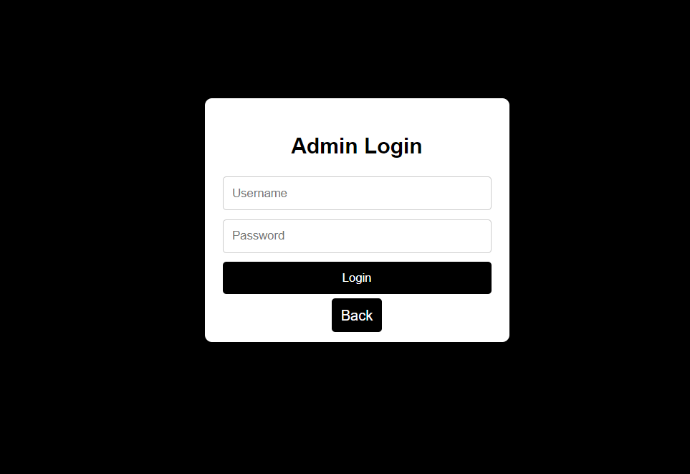

* Enter your credentials and press Login
* Scroll till Add Question to the store section

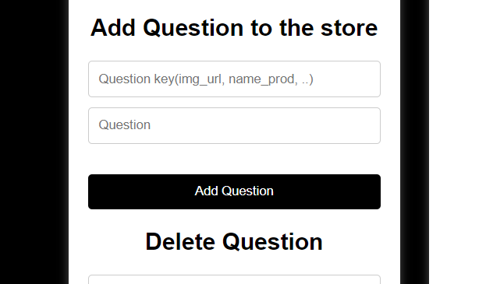

* Write the key for the question(can be any value) and the any question for specific product than press enter

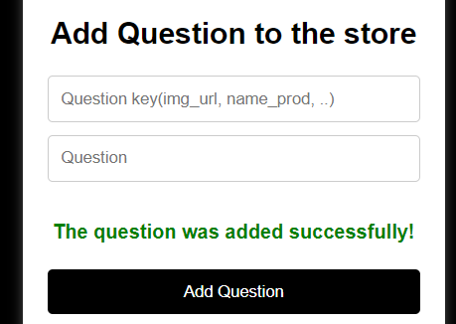

* If you see red text, most probably you have typed the key to the question that already exists

* Scroll down till Add group section

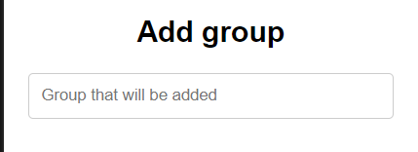

* Write the group name and press enter

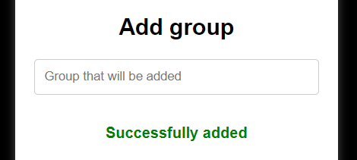

*if you see red text, most probably you have typed same group twice(you can see all groups in add product to the store section)

* Scroll up till Add Product to the Store section

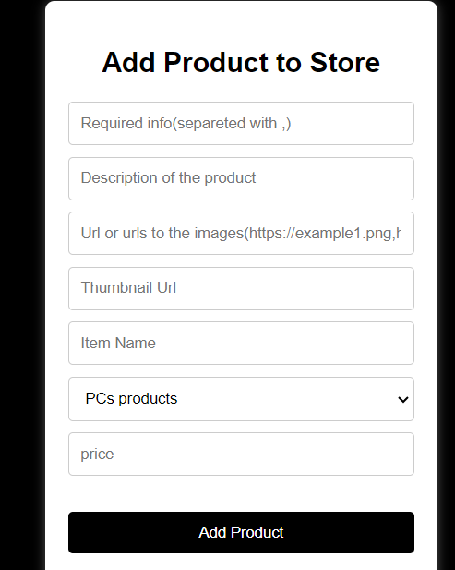

* Write in the required info input question keys separating with comma that you have added.(All question keys and their questions can be seen on the right)

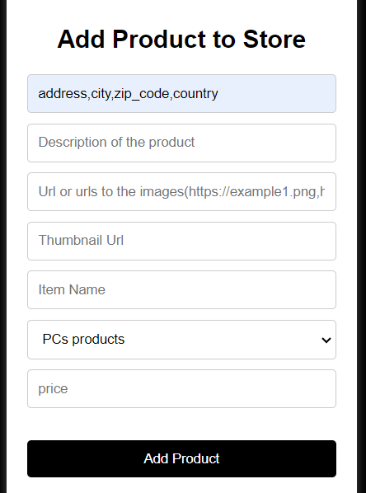

* Write the description for the product

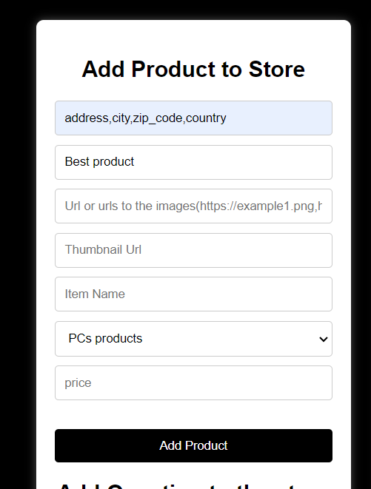

* Write in the url to image input the link to the image that will be shown in the product page(you can use multiple photos if you will separate them with comma)

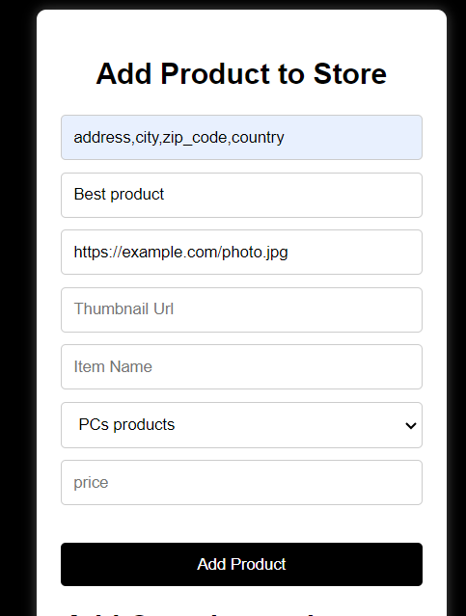

* Write the url to the thumbnail Photo

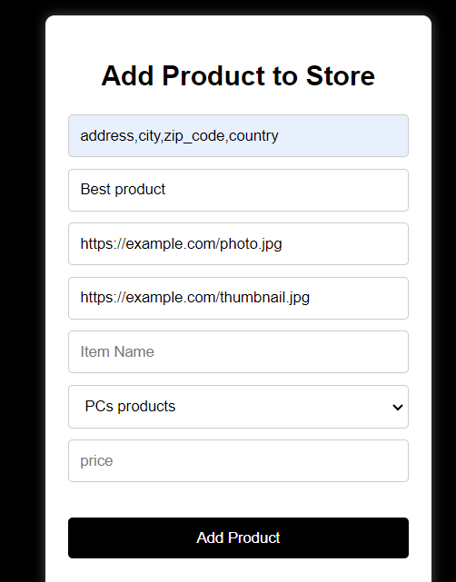

* Write the product name, choose group, write the price in dollars and press enter

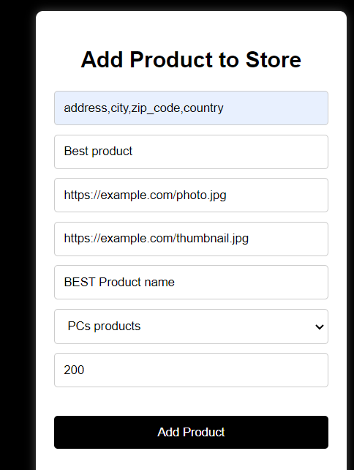

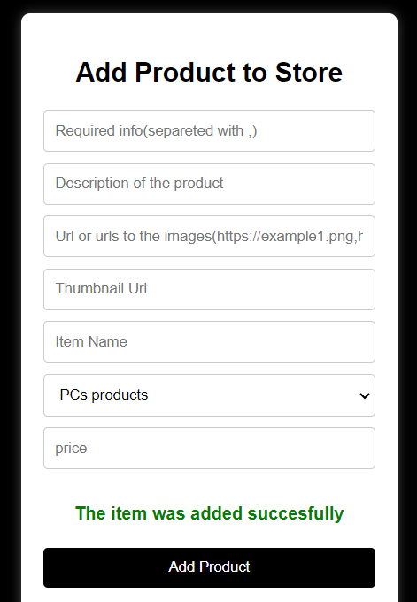

*if you have red text, most probably you have used question kay that does not exist

* Great! Now the product can be seen in your store!

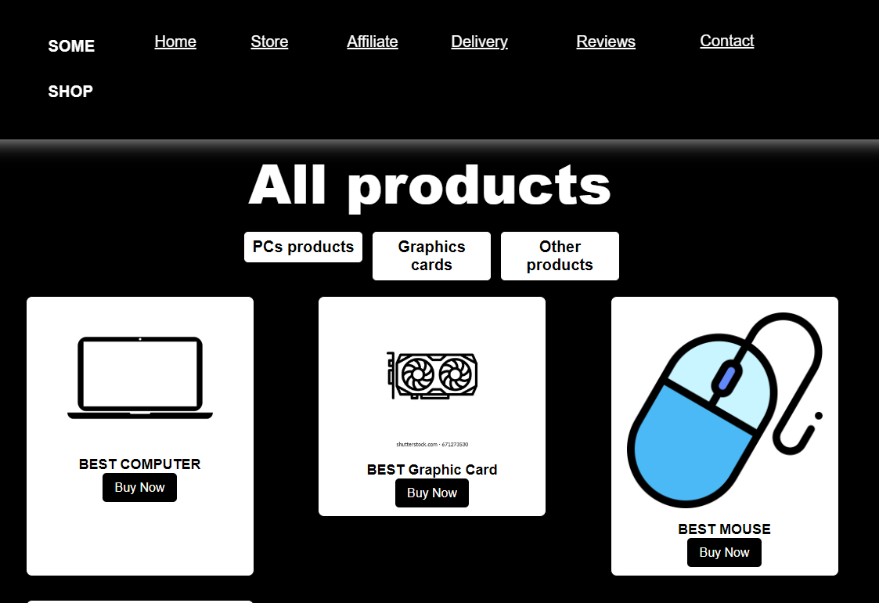

* **How to add products**
  + Write in the required info input question keys separating with comma that you have added.(All question keys and their questions can be seen on the right)



* Write the description for the product



* Write in the url to image input the link to the image that will be shown in the product page(you can use multiple photos if you will separate them with comma)



* Write the url to the thumbnail Photo



* Write the product name, choose group, write the price in dollars and press enter





*if you have red text, most probably you have used question kay that does not exist

* + Great! Now the product can be seen in your store!



* **How to delete questions**
  + Scroll till Delete Question section

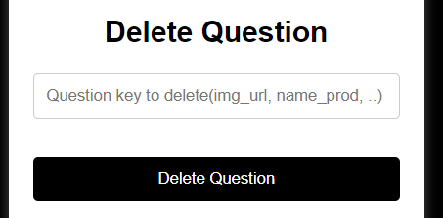

* Enter key to the question you want to delete and press enter

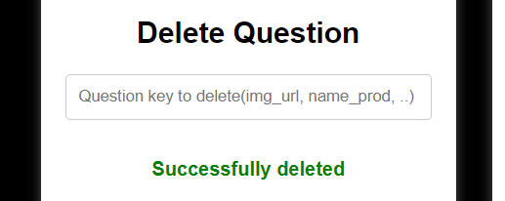

*if you have red text, most probably you have typed not existing question key

* **How to add questions for the product**
  + Scroll till Add Question to the store section



* Write the key for the question(can be any value) and the any question for specific product than press enter



* If you see red text, most probably you have typed the key to the question that already exists

* **How to add group**
  + Scroll down till Add group section



* Write the group name and press enter



*if you see red text, most probably you have typed same group twice(you can see all groups in add product to the store section)

* **How to delete group**
  + Scroll till Delete Group section

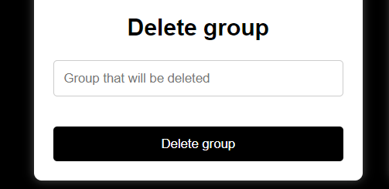

* Enter key to the question you want to delete and press enter

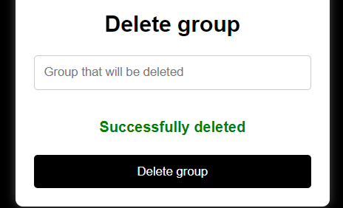

*if you have red text, most probably you have typed not existing group

* **How to add promocodes**
  + Press promocodes

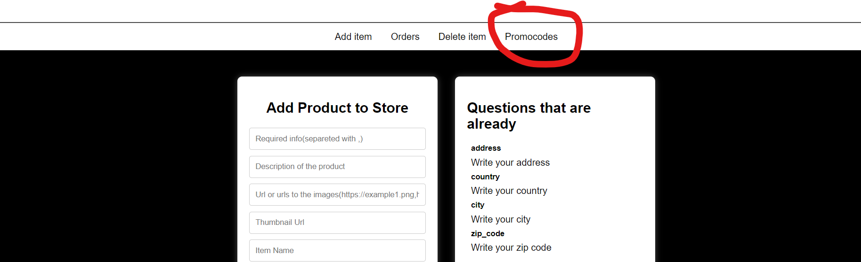

* Write promocode and discount

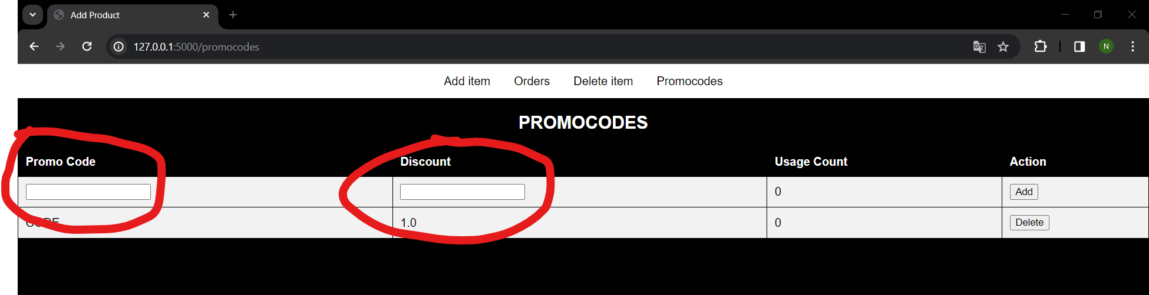

* Press Add

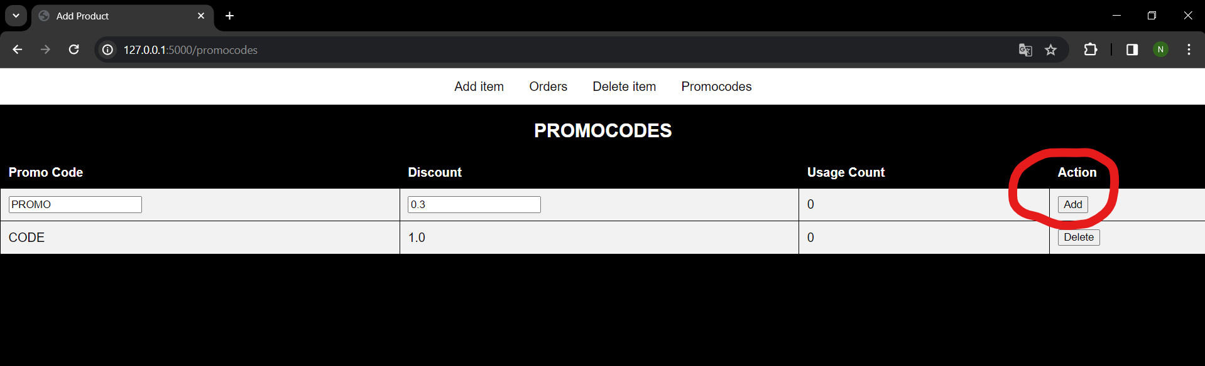

* Promocode will be shown on the table!
* **How to mark as done orders**
  + Go to the Orders page

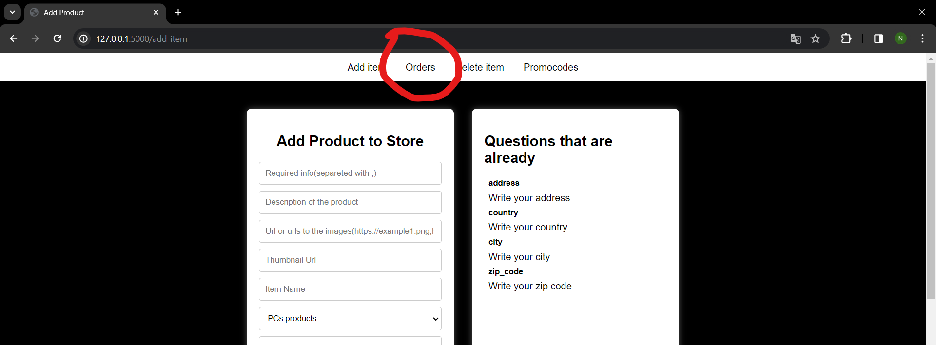

* Press on the Order Id that you want to see

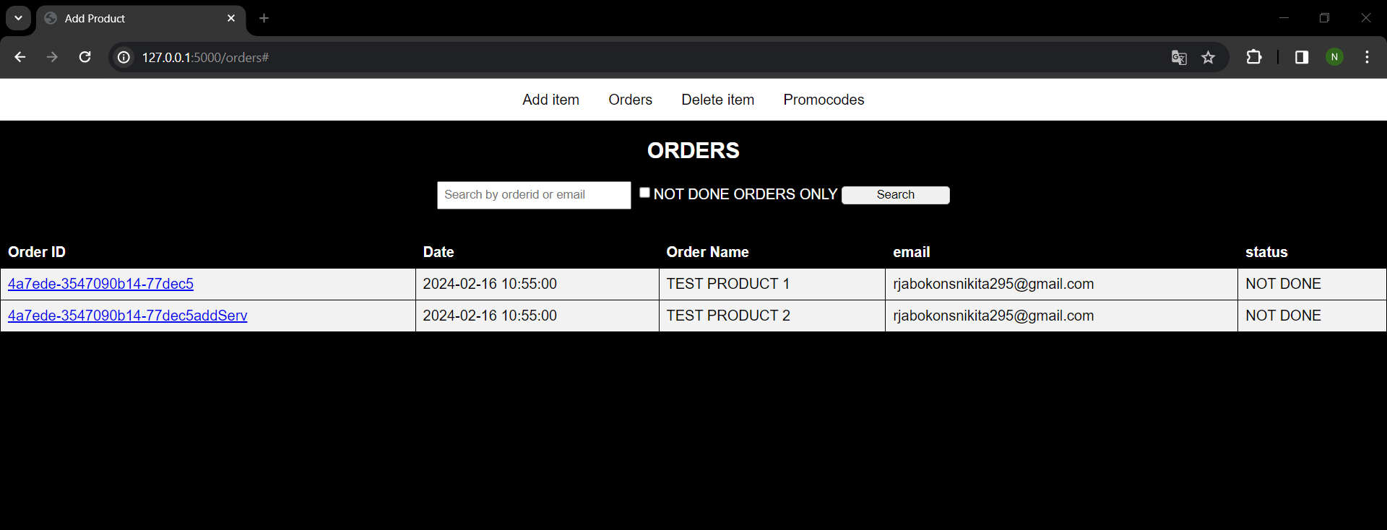

* Scroll down till the button mark as done and press it

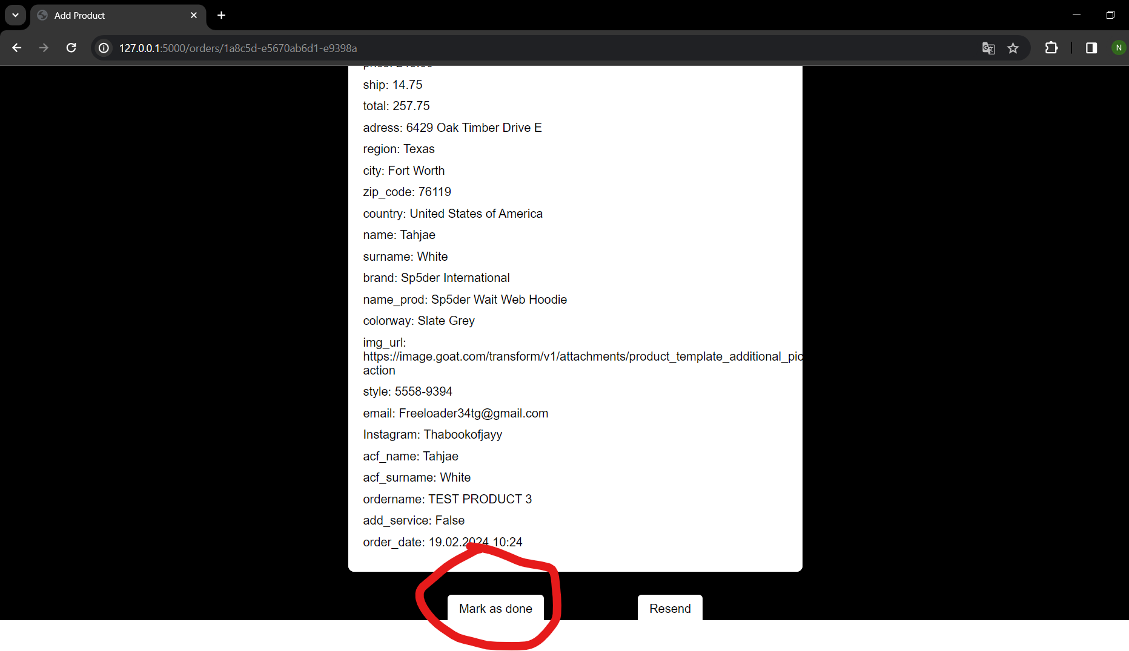

* **How to see order**
  + Go to the Orders page



* Press on the Order Id that you want to see



* **How to delete product**
  + Go to the Delete Item page

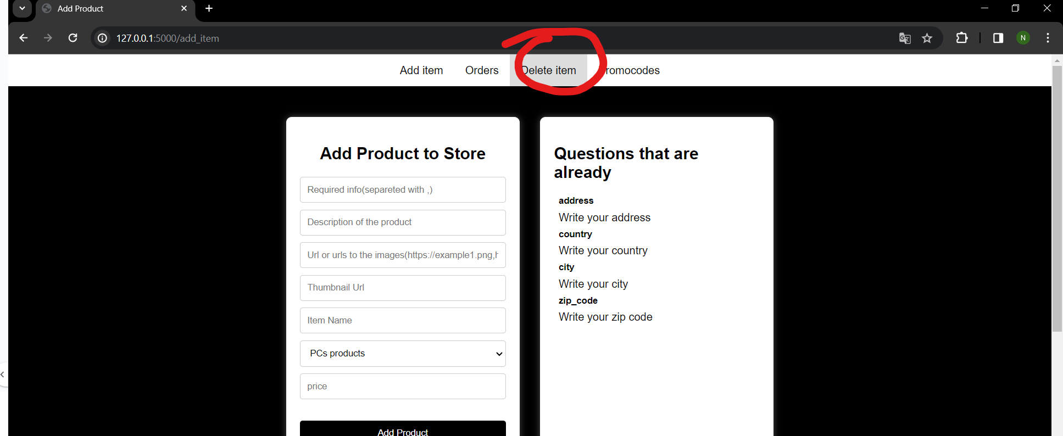

* Choose product to delete and press delete

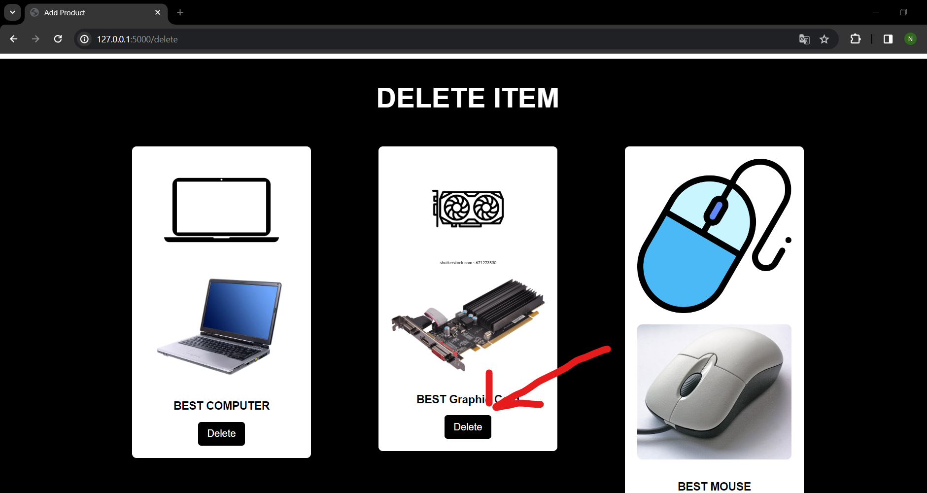

**Piemērotās licences pamatojums**

* Es izvelēju komerciālu licenci, jo jebkuras porgrammas mērķis ir nopelnīt naudu vai kapitālu, tāpēc es pats sapratu, kur ir iespēja automatizēt dažas lietas dropshipping procesā, samazinājot izmaksas.